11.55: a) 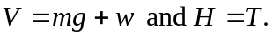To find the tension, take torques about the pivot point. Then, denoting the length of the strut by 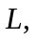
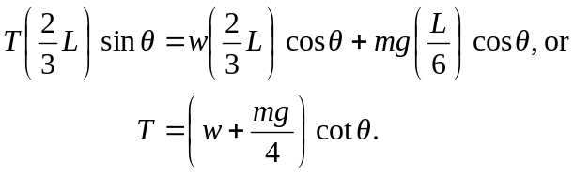

b) Solving the above for , and using the maximum tension for 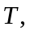

c) Solving the expression obtained in part (a) for 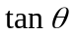and letting 